Recommended Actions for Prenatal Care Providers

Staff and protocols

• Educate staff and pregnant women about the importance of influenza vaccination during pregnancy and evidence related to its safety.

• Issue standing vaccine orders to prevent missed opportunities for vaccination.

• Establish an influenza vaccination reminder system in your practice.

• Offer vaccination to pregnant women at the earliest opportunity and throughout influenza season.

• Vaccinate all healthcare personnel in your practice to prevent spreading influenza to patients.

Patient education

• Provide a strong recommendation for influenza vaccination to pregnant women that addresses concerns around side effects to mother and baby

• Educate staff and postpartum women that breastfeeding is not a contraindication to vaccination.

• Post influenza prevention announcements and provide brochures to prompt vaccination requests.

• Advise family members and other close contacts of pregnant and postpartum women and infants that they should also be vaccinated against influenza.
For two years, Rhode Island met its goal of having 80% of new mothers vaccinated for the flu in the 12 months before their baby was born. In 2021, Rhode Island fell back to 74%, the lowest rate since 2015.

Background
The influenza (flu) vaccine has been proven safe in numerous clinical trials and is the most effective way to protect pregnant women and newborn babies from getting seriously ill with influenza. Newborn babies cannot be vaccinated, but they can receive protection from their mother’s vaccine while still in the womb.

The national medical associations American College of Obstetricians (ACOG), American Academy of Family Physicians (AAFP), and Centers for Disease Control and Prevention (CDC) all recommend that women who are or plan to become pregnant receive the inactivated flu vaccine (a different type, the live, attenuated flu vaccine, should not be used during pregnancy).

Figure 1. Percent of new mothers in Rhode Island who received the flu vaccine in the 12 months before their baby was born (2012-2021)
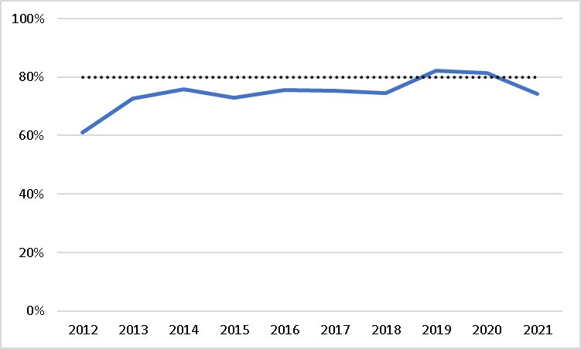
Data source: Rhode Island Pregnancy Risk Assessment Monitoring System (RI-PRAMS)

Factors associated with flu vaccination
Some populations were less likely to get the flu vaccine than others. For example, new mothers who had private insurance preconception, who were 30 or older, and who reported no perinatal smoking were all more likely to get the flu vaccine compared to new mothers who did not share these attributes. But the largest difference was between women whose healthcare provider offered the vaccine or told the woman to get one, and those whose providers did not:
 | Percent of new mothers in Rhode Island who got the flu vaccine*
Provider recommended or offered the flu vaccine | 81.2%
Provider did not recommend or offer the vaccine | 45.3%
*Women who gave birth in 2020 or 2021

Reasons for not getting the flu vaccine
In Rhode Island, the flu vaccine is generally covered by insurance or provided free of charge. However, there are still various reasons why not all women receive a flu vaccine in the year before giving birth. Not all women gave a reason for why they didn’t get the flu vaccine, and some women gave more than one reason.
It is important to note that all of these reasons can be addressed through patient education about the importance and safety of the flu vaccine for both woman and infant during the perinatal period.

Figure 2. Explanations offered by RI women who did not get the flu vaccine in the 12 months before giving birth (2020-2021)

Rhode Island data
The Rhode Island Pregnancy Risk Assessment Monitoring System (RI-PRAMS) collects information on perinatal experiences and attitudes each year. The survey asks several questions related to the flu vaccine, including During the 12 months before the delivery of your new baby, did you get a flu shot? Note: in 2020 and 2021, the RI-PRAMS response rate fell below the 50% threshold set by the CDC. Estimates for those years have a higher risk of bias.

Endnote citation

